Abstract
The purpose of this project is to create a provenance-enabled office text editor that uses the cloud as storage for all provenance data. Due to suspicions of the cloud servers and perhaps other users, we must encrypt all provenance information before it is sent to the server. This document outlines the current system as well as potential future plans.
Introduction
There are several subsystems of this project. First, a trusted server and a cloud server must be acquired and relevant software must be written.
Second, the office text editor (in this case Open Office) must be enabled to actually collect and encrypt the provenance data. This data will ultimately be saved on the cloud as opposed to the local file structure.
Server Setup and Server System Interaction
The following diagram provides a high level diagram of the provenance system.
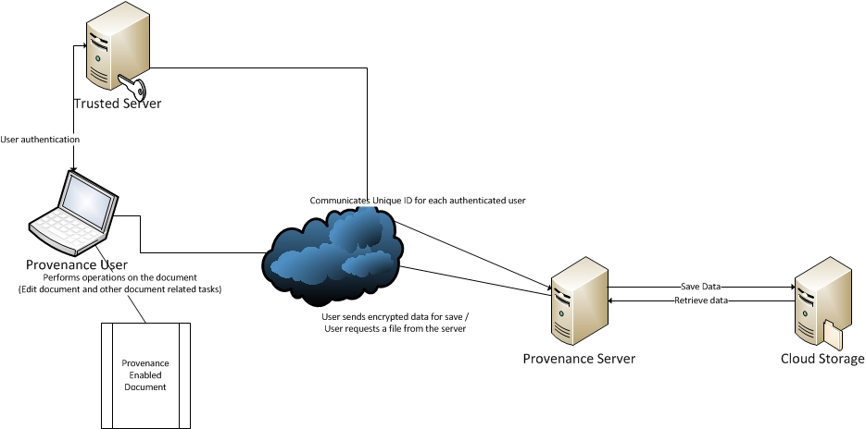
Fig 1: Block diagram of the Provenance System
The main entities in this system are listed below and a brief description of their responsibilities is provided.

Trusted Server (TS)
The main task of the trusted server is to authenticate requests from a Provenance Enabled Tool (PET) and communicate/generate keys for consumption by PET. If the request is valid, it will generate a session-id for the authenticated request and communicate it to the Provenance Server (PS). It will also send this session-id to the PET along with generated key. This trusted server will be part of the internal network of the organization which uses the Provenance Enabled Tool (PET).
Provenance Server (PS)
The main task of the Provenance Server is to save and retrieve the encrypted provenance document on untrusted cloud servers. Whenever the user performs a save operation, the encrypted data is saved onto the cloud storage server. When a user performs an open operation, the corresponding data is retrieved from the cloud storage server. Here, the operations open, save correspond to the command sent to the Provenance Server. Based on the type of command, the Provenance Server performs the appropriate action. In the current implementation, all the PET’s will connect to a particular TCP port and send the corresponding message. This message is composed of two parts:
- Command
- Data
The Command indicates the type of operation desired and the rest of the message will contain data. Currently the Server does not authenticate any request that is directed at the dedicated TCP port.
In the proposed implementation, every PET will first connect to a Trusted Server (TS) and once authentication is successful, it will receive a “SessionID”. This SessionID is also communicated to the provenance server. Any valid request should specify this SessionID followed by the message. The Server will first validate the SessionID and then perform processing of the message. It then sends back an appropriate response to the PET.
The following diagram shows the generic interactions that take place between the PET, TS and PS.
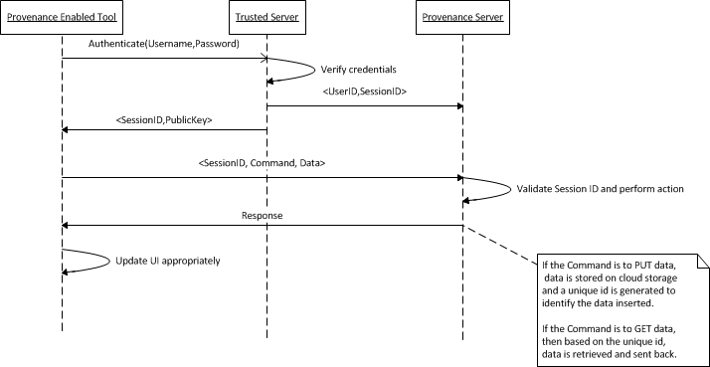
Fig 2: Outline of the interactions between PET, TS and PS
The SessionID will be regenerated after certain time interval (say 15 minutes), and will be communicated to the PET and PS.
Questions
- This SessionID mechanism was brought into the system to identify valid requests and commands to the PS. But still any malicious entity can capture this session id and use it to send invalid requests that can cause a denial of service. Can this scheme be improved to guarantee the anonymity of the user and still ensure that only valid requests and commands be processed by PS? In short, can this scheme be made more reliable?
- The data sent to the server as part of the message is being encrypted using a scheme similar to that explained in the “Fake Picasso” paper. The scheme currently being used in the system is explained in the next section. Can the SessionID and Command be hashed using an algorithm such as SHA256 to prevent sniffing? Is there a better mechanism?
Provenance Collection System
The provenance collection must be implemented in the user's computer (with a key generated by the trusted server) because the cloud server is not trusted.
Data Encryption Scheme
Each provenance event in a Provenance Document (PD) is captured and encrypted using the following scheme:
P_{i} = {U_{i}, W_{i}, hash (D_{i}), C_{i}} where
- U_{i} = Username of the principal
- W_{i}= E(w_{i}), where w_{i} is the current provenance event. AES is used to encrypt this.
- hash (D_{i}) = hash of the newly modified content of the document
- C_{i} = entry integrity checksum
Here C_{i} = S_{Ui}( hash(U_{i} , W_{i} , hash (D_{i})) | hash( C_{i-1} )), where S_{Ui} is the private key of the particular user.
How Provenance Data is collected
An overall view of the provenance collection system is given by the following diagram:
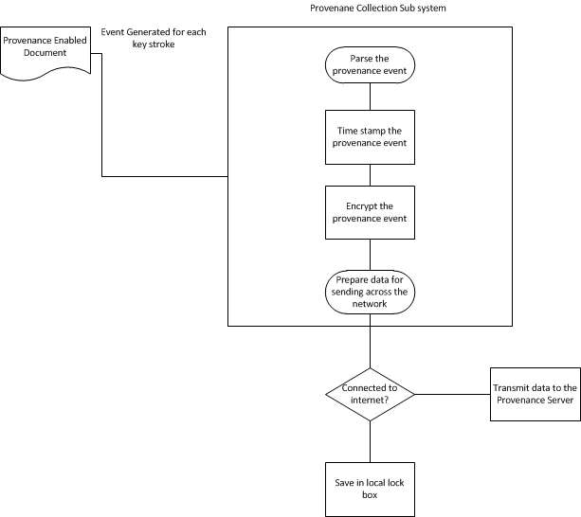
Fig 3: Major operations of the provenance collection system
To enable the Open Office text editor to collect and encrypt provenance data, UNO framework is used. The generic implementation of Open Office (at least the parts that we must interface with) is illustrated by this diagram:
(Insert UML Diagram of UNO or whatever)
The use of the UNO framework is the first biggest problem. Open Office is built entirely on this framework. If there are security vulnerabilities in the UNO framework, then those vulnerabilities will also be carried over to any aspect of the provenance collection. The ways that the provenance code actually interacts with this framework will be discussed next.

Document Initialization
The system begins with the creation of a Provenance-enabled Document. This involves interacting with the trusted server to indicate that a new provenance document should be created. The trusted server will have to generate two keys: One for the user to encrypt provenance events and another for the cloud server to recognize the user. (These keys are both sent to the user.) If a new user wishes to access the document, they would be assigned two keys as well.
Opening and Closing Provenance Documents
When Open Office starts, the user has the option to open a pre-existing Provenance Document. To do this, they must register with the Trusted server to get a new key to identify that user to the cloud server (this key is always refreshed every time the document is opened).
After the document is opened, Open Office performs some basic initialization to actually create the visible “editor” that then appears on the screen. This involves the creation of a “Model”, a “View” and a “Controller”. The following diagram shows the interaction between these parts of the system.
When the user types, for instance, the controller is the object that actually receives the key press. The controller then delegates this action and deciphers it since the action might not be related to the text of the document itself.
As an example, if Control -- C is pressed, this is a “copy” hotkey shortcut which does not yet affect the “Model” which is what stores the document. How this affects provenance might be important later, but currently, we ignore this.
After the controller deciphers the change, it will modify the “Model” (i.e. the document data structure) accordingly. This is when the document fires the “modified” listener, and the Provenance Listener will be notified that a change occurred. The listener will then parse through and acquires the details of the change into a provenance event. After acquiring the details, the listener will also timestamp the event with information about the user, date, and time.
Once the provenance event is created and time stamped, it is then encrypted. Right now, the encryption is done in the provenance listener, but as the system progresses, we may wish to handle this is a separate thread because encryption of the provenance takes the most time. The encryption is done using the Crypto++ library; while we believe this library is secure, we don’t know for certain.
Finally, the system takes the encrypted event and then sends it across to the cloud server using the ZMQ socket library. Right now, this is again done instantaneously, but in the future, this should be done in a separate thread, since the user does not need to be connected to the internet for the provenance to be saved. Furthermore, we do not want to “wait” for this data to send before continuing on with editing the document. This would frustrate the user.
How would this work? The data would be stored in a protected location before it is sent. When the user is connected to the internet, a separate thread will load the data in this protected server to the cloud server. If the user managed to tamper with this location before the data is uploaded, all of their current changes will be deleted as well, forcing a re-sync with the server. If the user is connected to the internet, then the data will be sent as it is acquired.
Questions
- Is the Crypto++ library appropriate and secure in this case?
- Should we continue following this scheme or should any modifications be done to this scheme?
- What are the potential attacks on the UNO framework when we actually collect the provenance?
- What are ways to protect the provenance that occurs when editing the document? Again, the provenance collection is coming from a listener in the UNO framework, which we should assume is not secure.

